***Practice Homework***

*Kubernetes*

Cloud Services (Introduction)

Teacher: Mr. Zheng Li

Student: Juan Albornoz

1. 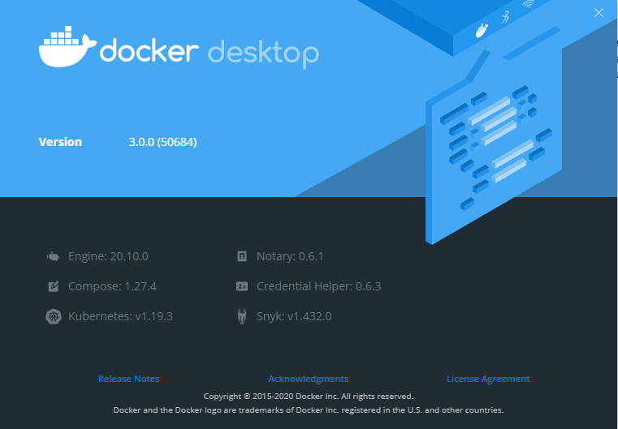Since I was working (in the recent laboratories) with the utilities of DockerToolBox on Windows 10 x64 but now it´s deprecated. Besides I´ve already started to have issues on the core´s inicialization of the tool. I installed Docker Desktop instead and this include a graphical interface.

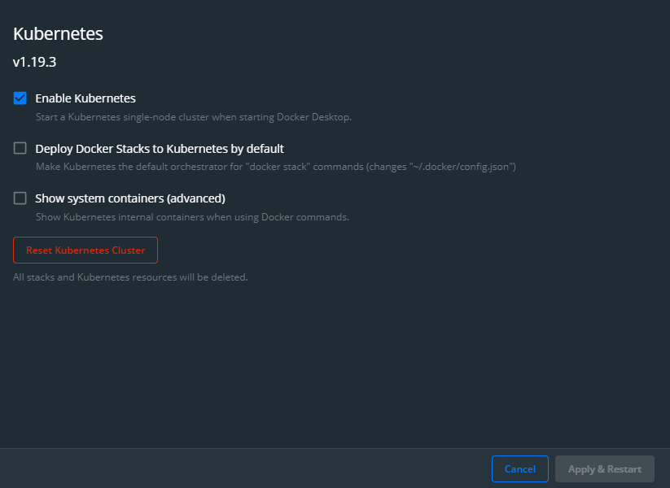

*Kubernetes was installed by just activating the installation in the Docker Desktop menu.

1.1. Installed:

* Python 3.9.0
* Flask 1.1.2
* Docker Desktop 3.0.0 (50684)
  + Dockerfile
  + Lab9.py
  + Requirements.txt
    - Flask
* Kubernetes v1.19.3



* 1. Having a containerized application test It can be mounted successfully:

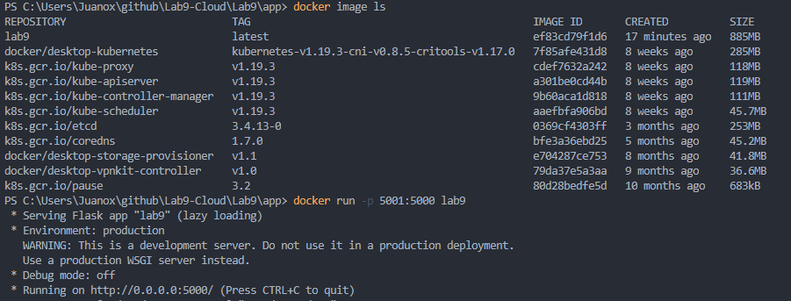

* 1. Changed the context used by Kubernetes by running:



* 1. Also the node is showed by the command:



* 1. The deployment.yaml file give the instructions to Kubernetes with the following parameters:
* replicas: The number of Pods created
* port & targetPort from Kubernetes and Docker
* spec: Specifications of the container:
  + name
  + image
  + containerPort
  1. Deployment:

kubectl apply -f deployment.yaml

* 1. State:

kubectl get services

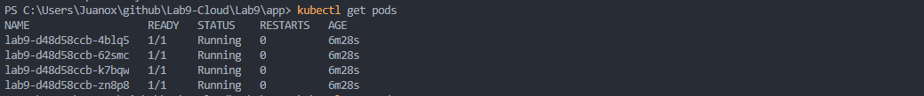kubectl get pods